DOWNTOWN CLASS DESCRIPTION

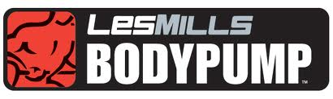A rapid fat-burning class that uses barbells to give you the fastest way to tone and condition muscles! After an exhaustive study, BODYPUMP was verified by The University of Auckland as providing the fastest body fat loss of any fitness class.

AB FITT – 15 -minute ab workout utilizing balls, bands, weights and gliders.

POWER YOGA- A dynamic physical practice designed to empower you through flowing movements, clear language and accessible poses. All levels are welcome.

SPINNING
45-60 minute ride taught within one of the Energy Zones (Endurance, Strength, Interval, Race Day and Recovery). Each class is taught within a certain Heart Rate parameter and cadence range. This class will fill the needs of the average cardio exerciser and the triathlete alike. Voucher ticket required for all classes. Tickets distributed at the front desk.
TABATA CARDIO TRAINING
The basis of Tabata Training is 4 minutes of intense interval training/circuit training. This Tabata based class will focus on cardio. The class can be done with a number of different exercises the idea is to use an exercise that gets the whole body involved or at least the major muscle groups – for maximum caloric burn. Intermediate to Advanced Exerciser.

TABATA BOOT CAMP
Create the warrior in you. Combination of cardio, strength, and core conditioning.
All levels.

Total Body Strength –
Total body workout utilizing bars, bands, balls, dumbbells, and gliders.

